**The Main Task** is to running preparing SQL scripts and install needed objects for load external reference T_Languages.

**Task Results:**

* Create sql scripts to show All created Tables and Views – Screenshot

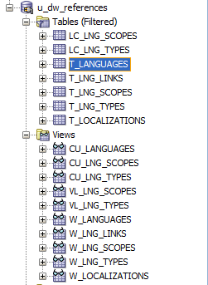

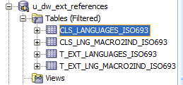



* Create DataFlow: Sketch Diagram of loading external References (MS Visio, MS Paint, MS Word, etc.)
* Create sql: Showing result of data on next objects:
  + t_localizations

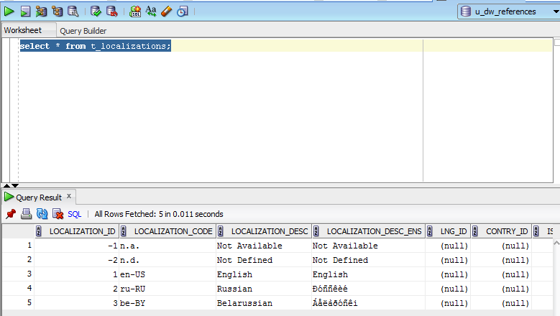

* + cu_languages

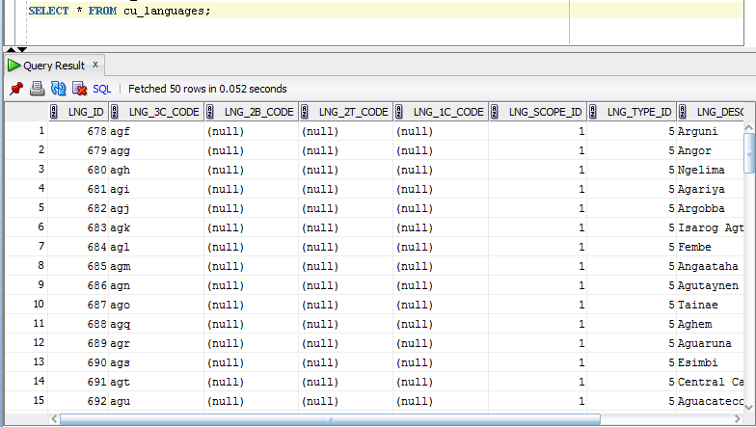

* + w_lng_links

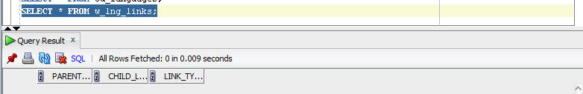

* + cu_lng_scopes

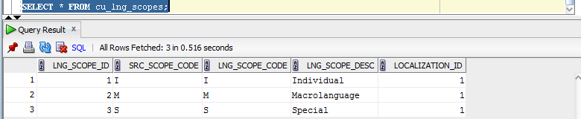

* + cu_lng_types

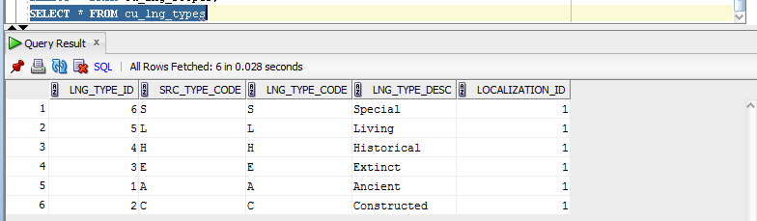

The Physical Diagram of T_Languages below:

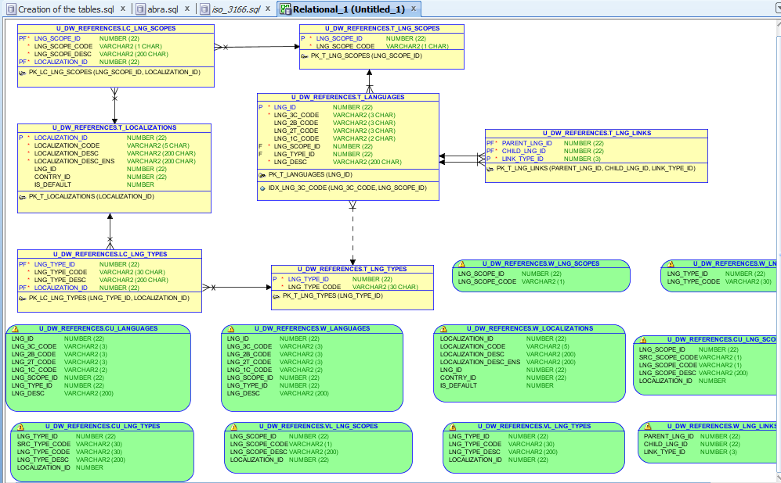

## Task 02 – Create load process for External references T_Countries

Description of External Resources:

|  |  |
| --- | --- |
| File Name | Path |
| iso_3166.tab | …\Topic 06 - Star Schema Basics\External_References |
| iso_3166_geo_un.tab | …\Topic 06 - Star Schema Basics\External_References |
| iso_3166_geo_un_contries.tab | …\Topic 06 - Star Schema Basics\External_References |
| iso_3166_groups_un.tab | …\Topic 06 - Star Schema Basics\External_References |
| iso_3166_groups_un_contries.tab | …\Topic 06 - Star Schema Basics\External_References |

**The Main Task** is to develop SQL scripts and install needed objects for load external reference T_Countries.

**Task Results:**

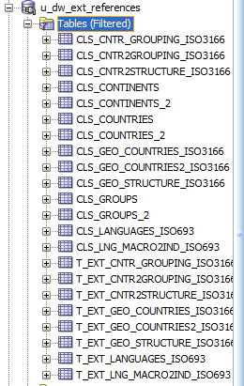

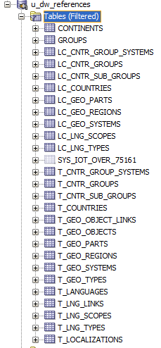

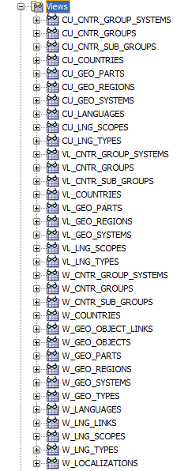

Select from main tables

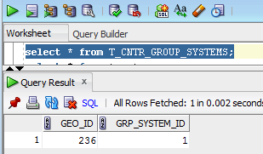

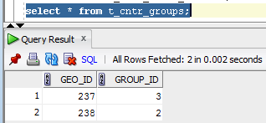

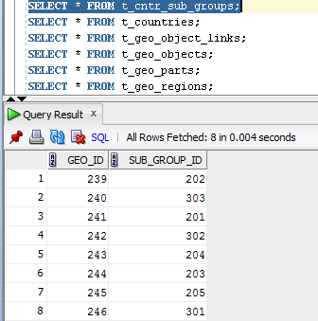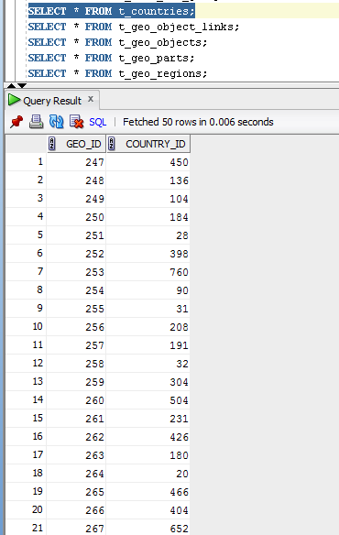

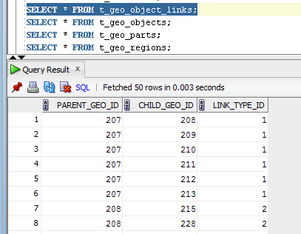

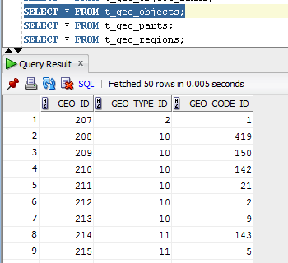

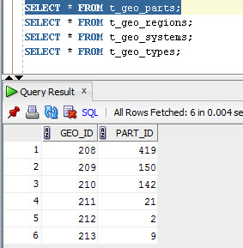

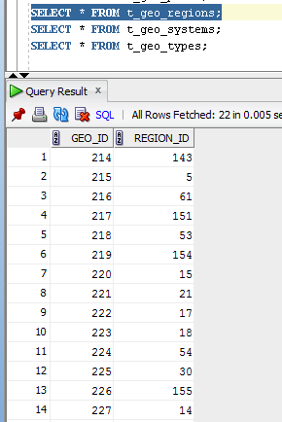

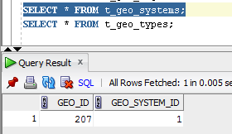

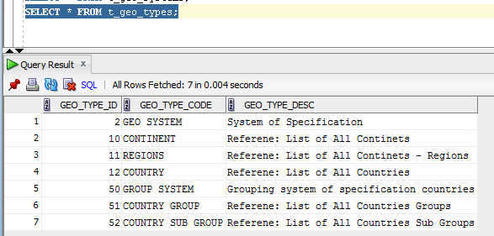

# OLAP – Business analyses task

Create any business analyses task for interesting for your business. The main idea is to use next main dimension:

* Time
* Geo-Location – T_COUNTRIES

## Task 03 – Solution concept – Business background

**The Main Task** is to create Solution concept of yours any business analyses task. You should use Developing Model, that described on MTN.NIX.07.Oracle DB.DWH_courseware06_Star Schema Basics.docx.

**Task Results:**

Create Solution Concept document, which contained next chapters:

Overview

Business Background

Benefit

Requirements

Business Requirements

Technical Requirements

Solution Sketch

Source Tables structure

Summarize Data Plan

The solution concept is situated in Solution concept.docx.

# OLAP – Develop Star-Scheme and SnowFlake Scheme.

Star Physical diagram.

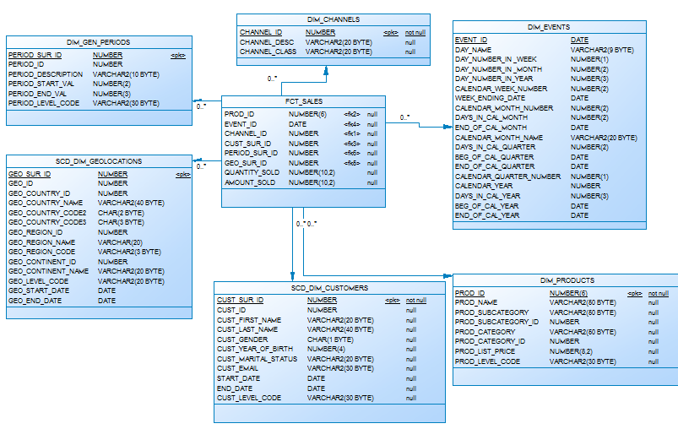

Star Logical diagram.

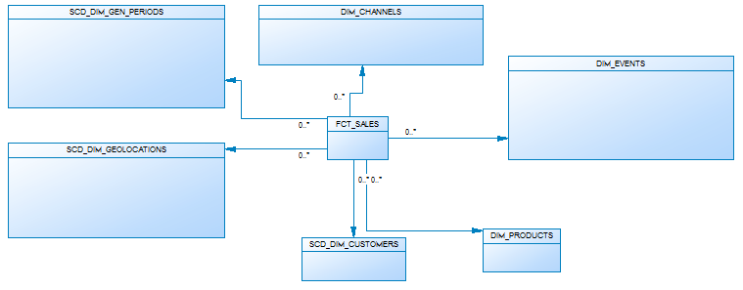

Snowflake Physical Diagram

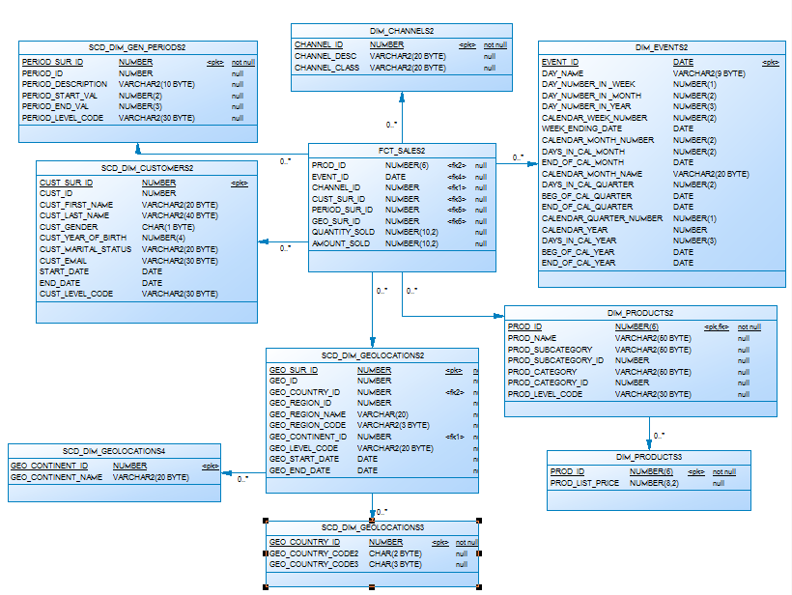

Snowflake Logical Diagram

